Multiples of three

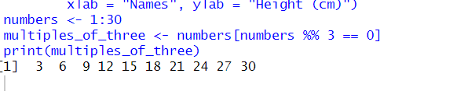

Sorting ascending and decending

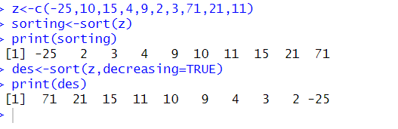

Graph scatter

